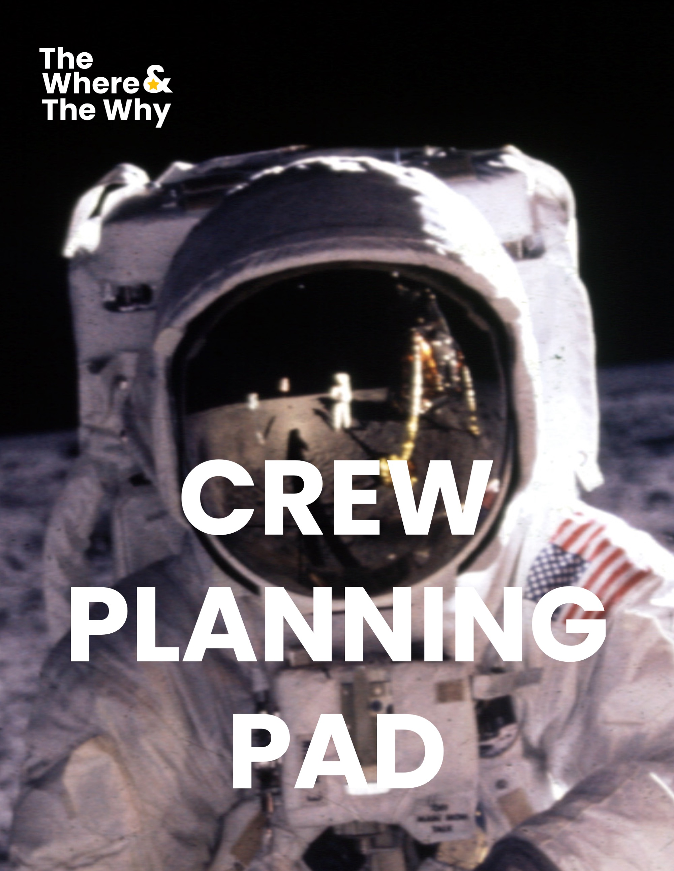
The Where and The Why Crew Planning Pad
Welcome aboard, Crew Member ‍
You're about to embark on an exciting mission to transform your organization's future. This Crew Planning Pad will prepare you for launch, ensuring you're ready to contribute to your team's strategic planning journey.
Mission Overview – The Where and The Why
The Where and The Why is a proven strategic planning approach that has transformed hundreds of teams across diverse industries. Think of it like planning a mission to the Moon – you need both a clear destination and powerful rocket fuel to get there.
This Crew Planning Pad contains two vital mission preparation activities:
- Define The Where 🌕 A future Vision exercise to map out your organization's future trajectory and help shape an ambitious goal that will align your entire crew.
- Define The Why 🔥 A Purpose discovery mission to gather evidence that reveals why your organization exists and its impact on the world.
Ground Control Guidelines
- Complete all pre-launch activities before your scheduled sessions
- Be honest, bold and creative in your responses
- Don't discuss your Crew Planning Pad prep work with other participants until the sessions
Your Role in the Mission
As a valued Crew Member ‍ your unique perspective is crucial to mission success. Your preparation will fuel rich discussions when the team comes together, helping craft a shared Moonshot goal and uncover its deeper Purpose.
Ready for some pre-launch planning? Let's begin! 🚀

Define The Where Vision & Moonshot Exercise
Imagine it's three years from now and your organization has achieved extraordinary success. What does that look like? This exercise helps you envision your organization's future state in vivid detail, which will help inform an ambitious Moonshot goal for your team.
Think big! Don't let current constraints limit your imagination. When President Kennedy announced the goal of reaching the moon in 1962, NASA's engineers were still using slide rules (there were no computers!) and many thought it was impossible. Yet just seven years later, humanity left its first footprint on the lunar surface. Your Vision of what's possible might seem ambitious today, but that's exactly what we're aiming for.
Your Task: Envision your organization three years from now. Answer the following questions in as much detail as possible:
In three years’ time...
1. What are we known for?

2. What customers do we serve?

3. What products/services do we offer?

4. What is our business model?

5. What are our areas of growth?

6. What geographies do we serve?

7. What does our team and culture look like?

8. Have we won any awards? If yes, what awards and what for?

9. Do we have any social responsibility initiatives?

10. What is our turnover/profit?

11. What will we NOT be doing? (Sometimes knowing what you won't do is as important as knowing what you will do!)

12. Bring 2-3 pictures that represent your Vision for the team in 3 years' time.

13. Is there anything else you imagine for our company not covered above?

Based on your Vision above, what's your idea for our 3-year Moonshot?
(Think of one ambitious, measurable goal that would transform our organization)

Tips for Success:
- Be ambitious but specific
- Think beyond current limitations
- Consider both practical and aspirational elements
- Don't discuss your answers with others yet – save that for the group session!
- For the pictures, these can be from magazines, online images, or even your own sketches

Remember: Your thoughtful preparation will contribute to a rich and energizing group discussion where we'll craft our shared Vision of the future together. Have fun with this exercise – let your imagination soar as high as the Moon

Define The Why Purpose Show & Tell Activity
Every organization exists for a deeper reason beyond just making money or delivering products or services. This activity helps uncover that deeper "Why" - the meaningful impact your organization has on people's lives and the world. Think about what gets you excited about your work, the difference you make to others, and the positive change your organization creates. Your responses will contribute to an energizing group discussion where we'll discover our shared sense of Purpose together.
This is your chance to get creative and have fun! We're asking you to gather items that represent your organization's Purpose in unexpected ways. Maybe it's a customer thank-you note that made you smile, a photo that captures a proud moment, or even a song that embodies your team's spirit. There are no wrong answers – the more diverse and imaginative your choices, the richer our conversation will be.
Your Task: Gather 5 items that represent why your organization exists and its impact on the world.
These could be:
- Photos or images
- Customer testimonials
- Physical objects
- Songs or videos
- Anything creative that captures your organization's Purpose
For each item, note:
Item 1: [Description and why you chose it]
Item 2: [Description and why you chose it]
Item 3: [Description and why you chose it]
Item 4: [Description and why you chose it]
Item 5: [Description and why you chose it]
Summary Statement: [Your short summary]
Your thoughtful preparation will contribute to a rich, insightful, and importantly fun discussion when the group comes together.
Important Tips:
- Think of things that fire you up
- Let your imagination run wild
- Complete this individually (don't discuss with the rest of the crew yet)
- For face-to-face session: Bring physical items/printouts that can be displayed on our "Purpose Wall" during the group session
- For virtual session: Prepare digital files to share on our digital "Purpose Wall"

EXAMPLE: Define The Why Purpose Show & Tell
Here's how a team member from SipForm, Perth-based maker of sustainable modular prefabricated buildings, represented their organization's Purpose:
Item 1:  Movie poster of "The Castle" with the quote "It's not a house it's a home and a man's home is his castle." | 
Item 2:  A picture of a bird's nest representing ecology, nature, family and home | 
Item 3:  Lego bricks built into a little house - representing the simple modular build that’s easy to assemble | 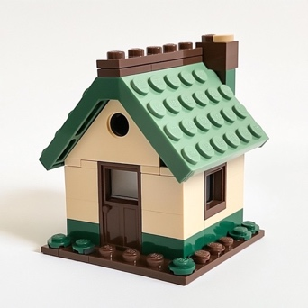
Item 4:  Song: "A Place in the Sun" by Stevie Wonder because of its inspirational lyrics about the Sun, the Earth, and nature.  There's a place in the sun, Where there's hope for everyone 🎶 | 
Item 5:  An email from a client about their new home:  "I can't express how grateful we are for our SipForm home. Every night, as I tuck my children into bed, I feel a sense of peace knowing we've made an eco-friendly choice for their future. Thank you for helping us create a cozy home that will care for our family, and for their families as well, in the years to come.” | 
Alex's short statement summarizing the above was:
“Crafting sustainable, cozy sanctuaries that families can call home for generations.”

